Application note 012d TVM

This application note aims to do the following:

- demonstrate R47/C47 Time Value of Money (TVM) through 10 worked examples.
- solve the TVM puzzles of Duncan’s on your calculator by R47/C47 RPN programs.
- document the TVM formulas in use in the R47/C47
- demonstrate the comparative performance of the R47/C47 models
Contents
Introduction 2
Learning outcomes of tutorial problems included: 2
Section 3: 10 problems from a worked out financial calculator tutorial. 2
Section 4: 1 Worked out TVM AMORT example from an HP tutorial. 2
Section 5: 16 numerical test cases from the calculator community as downloadable RPN programs. 2
Section 1: Reference to HP TVM calculators: 4
Section 2: Math Reference R47/C47 TVM: 5
1. Variable Definitions 5
2. Formulas implemented in R47 and C47 (DM42n) 6
3. General TVM Equation 6
4. Solving for Present Value (PV) 6
5. Solving for Future Value (FV) 6
6. Solving for Payment (PMT) 6
7. Solving for Number of Periods (NPPER) 6
8. Solving for Interest Rate (I%/a) 6
9. Amortization Schedule Calculations 6
10. Cumulative AMORT Values (periods p1 through p2) 7
Section 3: Worked out TVM tutorial Baker, Lin & Pursley 8
Section 4: AMORT tutorial 13
Section 5: Duncan’s collection of TVM stress tests 15
SwissMicros Forum post of Duncan’s (dm319’s) problem set 15
Results of Duncan’s TVM puzzle set as done by R47/C47, with accuracy of 34 digits 16
C47 & R47 relative performance on battery power, of Duncan’s tests above 17
TVM accuracy and speed of the R47/C47 calculators 18
Duncan’s TVM problems, programmed on C47 / R47 19

Introduction

The R47/C47 TVM implementation follows HP financial calculator conventions but requires explicit setup of payment and compounding periods. The five core TVM registers are n (number of periods), I/a (annual interest rate as percentage), PV (present value), PMT (payment per period), and FV (future value).

Special settings control pp/a (payment periods per year), cp/a (compounding periods per year), and Begin/End mode (when interest applies). Functions EFF/a->I/a and I/a->EFF/a convert between nominal and effective annual rates.

Learning outcomes of tutorial problems included:

Section 3: 10 problems from a worked out financial calculator tutorial.

The learning outcomes of Section 3 focus on TVM fundamentals from the Baker & Lin tutorial: understanding how the five core variables interact, setting payment and compounding periods correctly, and recognizing when to use Begin versus End mode.

Examples 3A/3B/3C demonstrate different problem approaches.
Example 5 teaches period conversion (annual to bi-weekly).
Examples 6 and 7 show how adding constraints changes the calculation.
Example 11 covers nominal to effective interest rate conversions.

- Example 1: Calculate FV given initial investment and time horizon
- Example 2: Calculate PV of a future amount
- Example 3: Compare lottery options (lump sum vs annuity stream)
- Example 3A: Same comparison using BEGIN mode
- Example 3B/C: Alternative approach comparing future values instead of present values
- Example 4: Calculate required annual savings to reach investment goal
- Example 5: Calculate bi-weekly savings (26 periods per year)
- Example 6: Determine required rate of return given savings capacity
- Example 7: Required return with existing capital and ongoing contributions
- Example 11: Convert nominal to effective interest rates for quarterly and daily compounding

Section 4: 1 Worked out TVM AMORT example from an HP tutorial.

- Example 1: Calculate interest paid, principal paid and remaining balance, given an initial loan vs payment numbers.

Section 5: 16 numerical test cases from the calculator community as downloadable RPN programs.

The learning outcomes of Section 4 shift to understanding the TVM functions by programming same: structuring complete TVM programs and multi-solve calculations.

Problems from dm319 (Duncan's) edge case calculator tests demonstrate straightforward setup and solving and progress to teach program sequencing when multiple TVM operations are required. Problems 5/5b and 6/6b specifically teach solver bias control, showing how to obtain different valid solutions by setting initial guesses.

All programs are available in the firmware distro zip file.

- Problem 1: Monthly mortgage payment over 38 years
- Problem 1b: Reverse calculation verifying interest rate
- Problem 2: Payment differential from rate change, then PV calculation
- Problem 3: Kahan's extreme test (60×60×24×365 periods)
- Problem 4: Zero interest rate round-trip (exposes floating point precision limits)
- Problem 5: Multiple solution test (default solver finds first root at 14.44%)
- Problem 5b: Biased solver finds second root at 53.17%
- Problem 6: Multiple solution test (default finds -36.89%)
- Problem 6b: Biased solver finds second root at 58.46%
- Problem 7: Near-zero FV with fractional payments
- Problem 8: Small interest rate precision test
- Problem 9: Period calculation in END mode
- Problem 10: Period calculation in BEGIN mode
- Problem 11: Sequential FV then I/a calculation
- Problem 12: Sequential I/a then FV calculation
- Problem 12a: Sequential I/a then FV calculation

Program 'Pall' executes the complete test suite with timing, and subroutine 'TT' logs results to text files. Execution times on USB-powered C47 (DM42, DM42n) and R47 hardware range from 0.4 to 20 seconds per problem depending on the versions.

Section 1: Reference to HP TVM calculators:
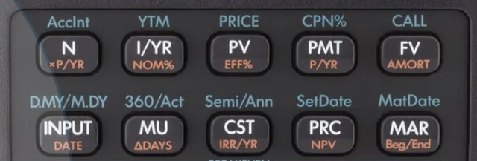
The HP 10bII+ shown in the image on the right is referenced throughout Section 3: Business Finance Essentials. That tutorial was originally written with the 10bII+ as its primary example and is therefore reproduced verbatim in this application note. As a result, terminology, key names, and examples in that section follow the conventions of the 10bII+, even when equivalent operations on other calculators may be entered differently. The 10bII+ represents Hewlett-Packard’s algebraic (non-RPN) financial calculator lineage. While it does not use Reverse Polish Notation, its internal time-value-of-money (TVM) model is mathematically identical to that of HP’s RPN calculators, making it a useful neutral reference when explaining financial concepts independently of entry method.
Photo HP10BII+, credit hp.com
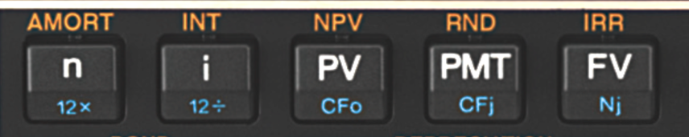
The HP-12C, the classic workhorse of the financial industry, is similar to most modern RPN financial calculators but differs in one key respect: interest rates are entered per period rather than per year, so an annual rate must be converted explicitly at entry. While this can appear unfamiliar to users of algebraic calculators, it makes the compounding structure explicit and avoids hidden assumptions.
HP12C major difference:
i is interest % per period
Photo HP12C, credit hp.com

The HP 30b, a later HP model, adds an RPN mode alongside algebraic entry, showing that differences among these calculators lie primarily in interface rather than underlying TVM mathematics. A subtle but important point is that apparent discrepancies in results almost always stem from differing conventions such as payment timing or rate entry rather than from different formulas; once these are aligned, all platforms yield the same numerical answers.
Photo HP30b, credit hp.com

The C47 / R47 follows the modern type, like the 30b. The functions in orange directly nod back to the HP models, where applicable:

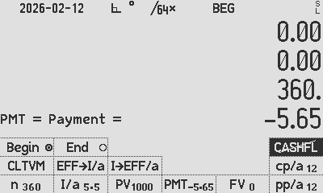
5 Standard TVM keys:
C47 / R47 TVM menu

⇒ The number of (payment) periods
⇒ The interest rate, I%/a (enter 10 for 10% per annum), a.k.a. discount rate or rate of return.
⇒ The Present Value
⇒ The Annuity Payment
⇒ The Future Value

Special options:
⇒ Input effective rate to I%/a
EFF→I/a
⇒ Convert I%/a to effective rate /a
I→EFF/a
⇒ Payment periods per year, generally 1 or 12.
⇒ Compounding periods per year, generally 1 or 12.
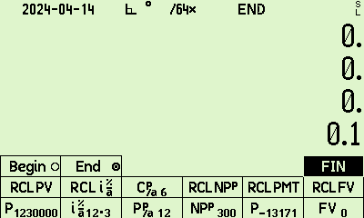 ⇒ Interest on the beginning of the period, or end of the period.

Section 2: Math Reference R47/C47 TVM:
This section gives the direct formulas used by R47/C47 in the TVM module.
The general TVM formula (3) can be used in a solver, but where possible, the analytic formulas are used. Should any formula fail due to numerical issues such as divide by zero or log of a negative number, the fallback generic equation is solved, if that might help.

1. Variable Definitions

Table of variables, as used in the TVN formulas below.
Variable | Description
PV | Present Value (principal amount today)
FV | Future Value (amount at end of term)
PMT | Payment amount per period
I%/a | Nominal annual interest rate (percentage), 5 entered for 5% per annum
NPPER | Number of payment periods (total payments)
PPER/a | Payment periods per annum (12=monthly, 4=quarterly, 1=annual)
CPER/a | Compounding periods per annum (12=monthly, 365=daily, etc.)
p | Payment timing: 0 = END mode, 1 = BEGIN mode

p is greyed out, as it is not a real accessible variable, but a R47/C47 flag, listed as ‘p’ in the formulas below.
p is controlled with the BEGIN/END buttons and the associated flag.

2. Formulas implemented in R47 and C47 (DM42n)

Nominal rate per compounding period (ic):
ic = (I%/a ÷ 100) ÷ CPER/a (1)

Effective interest rate per payment period (ip):
ip = (1 + ic)^(CPER/a ÷ PPER/a) − 1 (2)
Special case when CPER/a = PPER/a: ip = ic (2a)

3. General TVM Equation
0 = PV + (1+ip×p)×(PMT÷ip)×[1−(1+ip)^(−NPPER)] + FV×(1+ip)^(−NPPER) (3)
Special case (ip ≈ 0): 0 = PV + PMT×NPPER + FV (3a)

4. Solving for Present Value (PV)
PV = −[(1+ip×p)×(PMT÷ip)×[1−(1+ip)^(−NPPER)] + FV×(1+ip)^(−NPPER)] (4)
Special case (ip ≈ 0): PV = −PMT×NPPER − FV (4a)

5. Solving for Future Value (FV)
FV = −PV×(1+ip)^NPPER − (1+ip×p)×(PMT÷ip)×[(1+ip)^NPPER − 1] (5)
Special case (ip ≈ 0): FV = −PV − PMT×NPPER (5a)

6. Solving for Payment (PMT)
PMT = −[PV + FV×(1+ip)^(−NPPER)]×ip ÷ [(1+ip×p)×[1−(1+ip)^(−NPPER)]] (6)
Special case (ip ≈ 0): PMT = −(PV + FV) ÷ NPPER (6a)

7. Solving for Number of Periods (NPPER)

Case 1: No payments (PMT = 0)
NPPER = ln(−FV ÷ PV) ÷ ln(1 + ip) (7)

Case 2: With payments (PMT ≠ 0, ip ≠ 0)
NPPER = ln(A ÷ B) ÷ ln(1 + ip) (8)
A = −FV×ip + PMT×(1+ip×p) (8a)
B = PV×ip + PMT×(1+ip×p) (8b)

Case 3: Zero interest (ip ≈ 0)
NPPER = −(PV + FV) ÷ PMT (9)

8. Solving for Interest Rate (I%/a)

Requires iterative solution - no closed form exists: solved via the R47/C47 real solver in TVM mode
I%/a = 100×CPER/a×[(1+ip)^(PPER/a÷CPER/a) − 1] (10)
Where ip has to be solved for in Equation (3).

9. Amortization Schedule Calculations

Balance at start of period k (before payment):
Special case k = 0: BAL(0) = PV (11)
BAL(k) = BAL(k−1) × (1+ip) − PMT for k = 1, 2, ..., NPPER (12)

Interest paid in period k:
INT(k) = BAL(k−1) × ip (13)
Special case (ip ≈ 0): INT(k) = 0 (13a)

Principal paid in period k:
PRN(k) = PMT − INT(k) = PMT − BAL(k−1) × ip (14)
Special case (ip ≈ 0): PRN(k) = PMT (14a)

Balance after payment in period k:
BAL(k) = BAL(k−1) − PRN(k) = BAL(k−1) × (1+ip) − PMT (15)

10. Cumulative AMORT Values (periods p1 through p2)

Sum of interest paid:
ΣINT(p1→p2) = Σ(k=p1 to p2) [BAL(k−1) × ip] (16)

Sum of principal paid:
ΣPRN(p1→p2) = Σ(k=p1 to p2) [PMT − BAL(k−1) × ip] (17)
= PMT × (p2−p1+1) − ΣINT(p1→p2) (17a)

Remaining balance after period p2:
BAL(p2) = PV × (1+ip)^p2 − (1+ip×p) × (PMT÷ip) × [(1+ip)^p2 − 1] (18)
Special case (ip ≈ 0): BAL(p2) = PV − PMT × p2 (18a)

Verification (easy test) (for p1=1, p2=NPPER):
ΣINT(1→NPPER) + ΣPRIN(1→NPPER) = PMT × NPPER (19)
ΣPRIN(1→NPPER) = PV − BAL(NPPER) = PV − FV (20)

Section 3: Worked out TVM tutorial Baker, Lin & Pursley

From the great tutorial by Dr. Kevin Bracker; Dr. Fang Lin; and J Pursley at Pressbooks or Wayback Machine:
All references below coloured in yellow are directly taken from linked document, under the appropriate Creative Commons license NC4.0 by in this referenced document.
Example One:
6  7  10 000  0  Here, on R47/C47 you have to specify the details of compounding. Do 1 and will be defaulted to the same. Ensure End is set:.  is -15 007.30 | 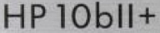  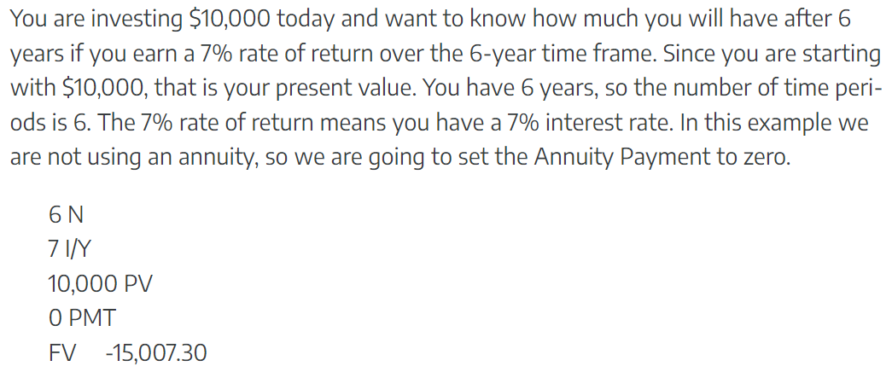

Example Two:
5  9  0  6 000  Here, on R47/C47 you have to specify the details of compounding. Do 1 and will be defaulted to the same. Ensure End is set:.  is -3 899.59 |   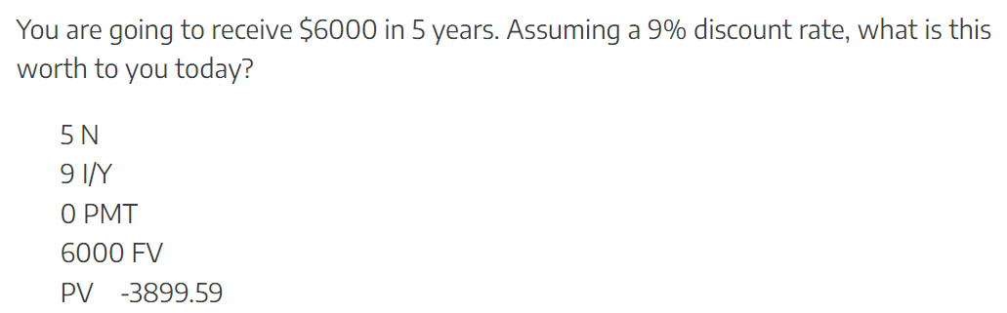
Note: light grey represents settings the same as the previous problem, i.e. no need to re-enter those from the one problem to the next. Do be careful when doing the problems out of sequence.

Example Three:
25  6  400 000  0  Here, on R47/C47 you have to specify the details of compounding. Do 1 and will be defaulted to the same. Ensure End is set:.  is -5 113 342.46 |   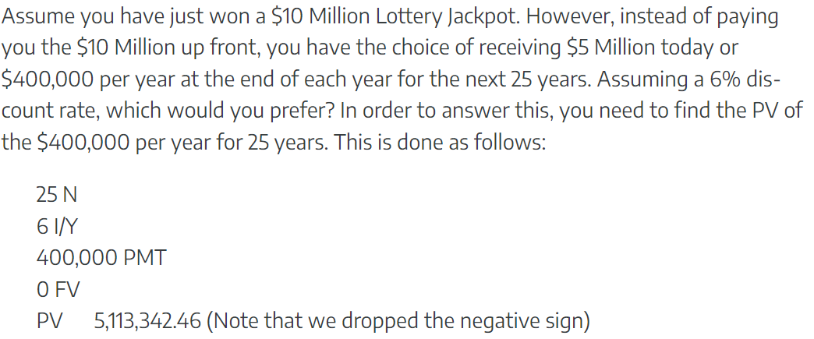  Our understanding is that the lure is 0.4M x 25 = 10M, vs. the single payment of half of that, but right now.  To get back to the original question, receiving the $10M in total over 25 years is clearly better than receiving $5M now!
Note: light grey represents settings the same as the previous problem, i.e. no need to re-enter those.

Example Three A:
All the same as Ex 3, set to BEGIN:  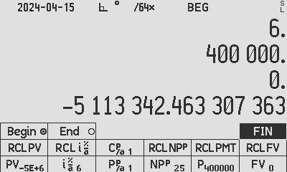  is -5 420 143.01 |   To be more realistic, as the first 400k will be paid immediately, set to Begin, and see the ‘deal’ being worth even more making it the right decision to take the deal.

Example Three B & C: calculating using future end values
R47/C47 Solution B:  25  6  5 000 000  0  1 .  is -21 459 353.60 | Although the original solution THREE A (in yellow above) is the most elegant, a more “hand-waiving” intuitive way (as opposed to the quickest way) to illustrate the compounding comparison better, is equally easily done on the R47/C47:  We simply compare the tangible future values of both deals instead of the ‘financial’ way of evaluating the current worth of a future investment: Clearly the same answer, that $23.3M is more convincing than $21.5M:
R47/C47 Solution C:  25  6  0  400 000  1 .  is -23 262 553.09 | B: We first check what $5M would do for us in 25 years:  25 N  6 I/Y  5 000 000 PV  0 PMT  FV $21,459,353.60 (dropped the negative sign) | C: Then what the “deal” would do for us in the same 25 years:  25 N  6 I/Y  0 PV  400 000 PMT  FV $23,262,553.09 (dropped the negative sign)  

Example Four:
20  10  0  1 000 000  Here, on R47/C47 you have to specify the details of compounding. Do 1 and will be defaulted to the same. Ensure End is set:.  is -17 459.62 | 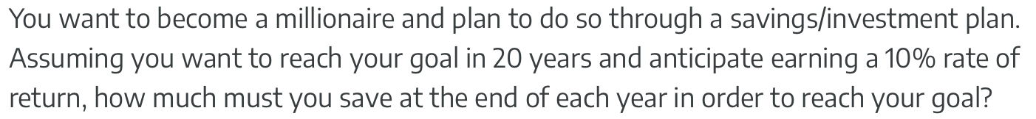    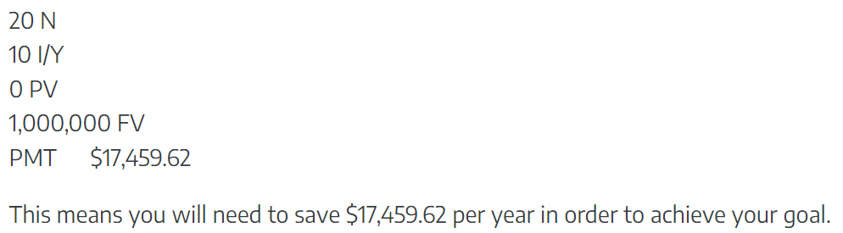
Note: light grey represents settings the same as the previous problem, i.e. no need to re-enter those.

Example Five:
R47/C47 has the setting Payment Periods Per Year, so type 26 and it is assumed the Compounding Periods Per Year is the same.  30 ENTER 26 X  10 (still the same as Ex 4)  0 (still the same as Ex 4)  1 000 000 (still the same as Ex 4)  Ensure End is set:  (still the same as Ex 4).  is -202.75 |   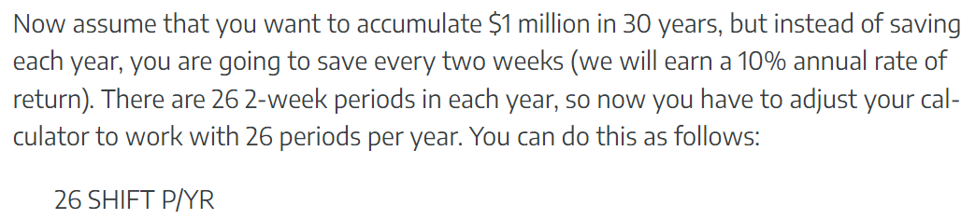  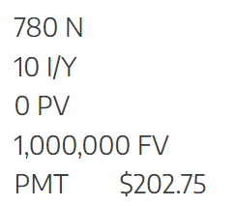
Note: light grey represents settings the same as the previous problem, i.e. no need to re-enter those.

Example Six:
R47/C47 has the setting Payment Periods Per Year, so type 1 and it is assumed the Compounding Periods Per Year is the same. (still the same as Ex 4, 5)  35  -3 000  0 (still the same form Ex 4, 5)  1 000 000 (still the same form Ex 4, 5)  Ensure End is set:  (still the same as Ex 4, 5).  is 10.89 % | 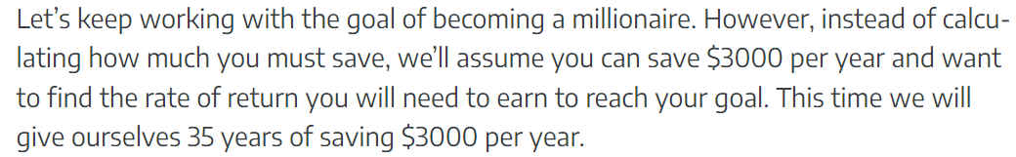    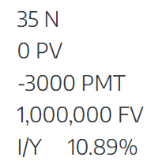
Note: light grey represents settings the same as the previous problem, i.e. no need to re-enter those.

Example Seven:
R47/C47 has the setting Payment Periods Per Year, so type 1 and it is assumed the Compounding Periods Per Year is the same. (still the same as Ex 4, 5, 6)  35 (still the same as Ex 6)  -3 000 (still the same as Ex 6)  -40 000  1 000 000 (still the same as Ex 4, 5, 6)  Ensure End is set:  (still the same as Ex 4, 5, 6).  is 7.63 % | 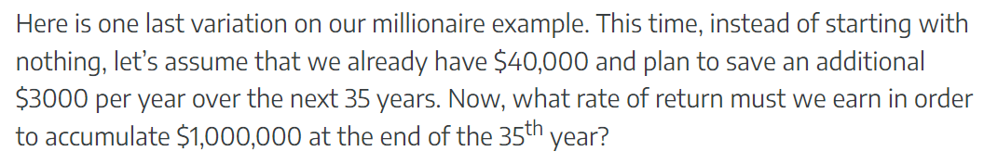    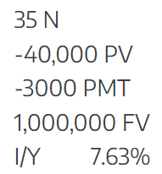
Note: light grey represents settings the same as the previous problem, i.e. no need to re-enter those.

Examples Eight through Ten are “Cash Flow Problems” cannot yet be done by C47:
Example Eleven:

7.8 to enter NOM% or Nominal interest value  4 for 4 compounding periods per year.  is 8.0311 %  I→EFF/a  (Or press 4 for 4 Payment Periods Per Year, which does not matter, but will always follow.)  pp/a | 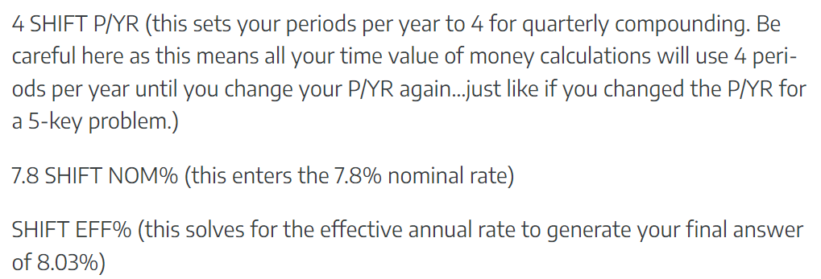  
7.6 to enter NOM% or Nominal interest value  365 for 365 Periods Per Year.  is 7.8954%  I→EFF/a |   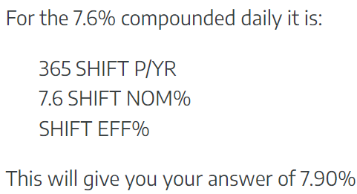

Section 4: AMORT tutorial

The HP 12C Platinum Loan Amortizations document from the hp.com web site is referred to below. All rights to HP, although the document claims no copyright and no license to use. All excerpts are verbatim, for educational use, and with corrections shown below in red.

Another tutorial may be found on the tvmcalc.com web site.

The examples below are from the mentioned HP 12C Platinum Loan Amortizations and were checked using a web 12C calculator: https://stendec.io/ctb/rpn_fin.html.

The C47/R47 provides two AMORT calculation modes: standard mode uses mathematically exact formulas and HP12C mode which emulates HP12C's iteration method.

The HP12C rounding rounds Balance to 2 decimals after each period and uses a 10-digit periodic rate. Enable the HP12C mode via TVN AMORT menu for exact HP12C compatibility.

Example 1:
A loan is taken out for $ 180 000, at 7.75% p.a., over 30 years. The question is how much money is paid off after one year, and how much interest is paid.

Set up the relevant TVM problem:  360  7.75  180 000  0  Here, on R47/C47 you have to specify the details of compounding. Do 12 and will be defaulted to the same. Ensure End is set:.  is -1 289.5420 | 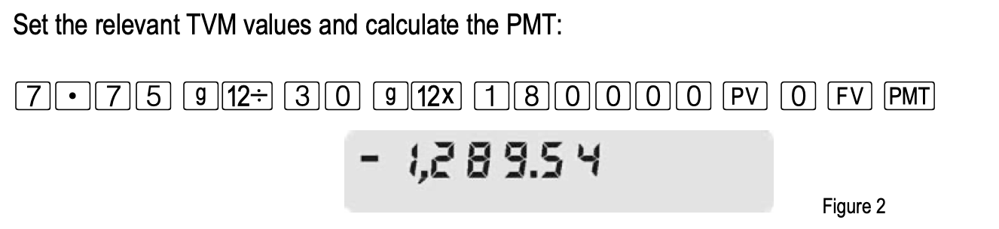  
To get the interest paid and the principal paid after 12 months: Set the first period to the first month 1 and the last period to the 12th month .  P1 ₁  P2 ₁₂  The total interest from month P1 = 1 to P2 = 12: press is -13 894.6655. With HP12C ticked, -13 894.66.  ΣINT  The amount of principal paid after the last month P2 = 12: press which is -1 579.8390 and with HP12C ticked it is -1579.82.  ΣPRN | 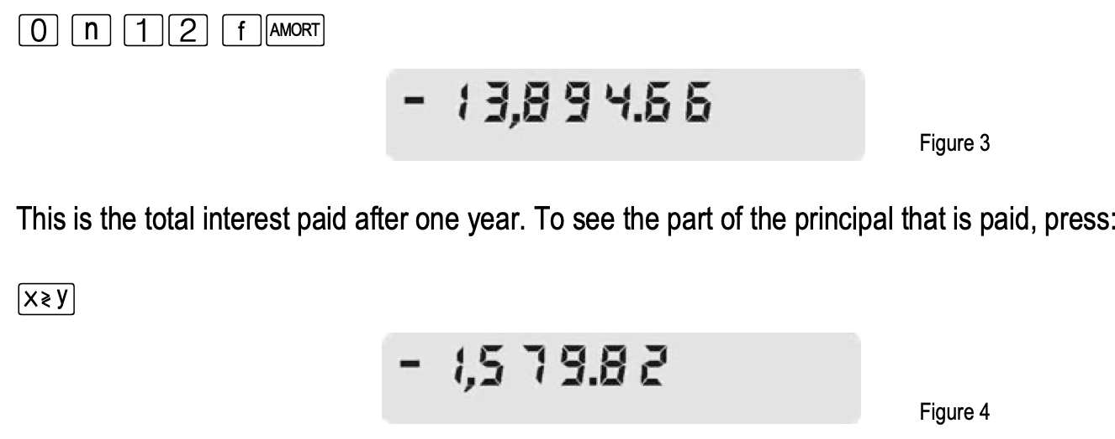  
To get the amount of principal left to pay after 12 months: press to get 178 420.1609. With HP12C ticked it is 178 420.18.  BAL  Operation is not identical with the HP12C’s “RCL PV”, as the C47/R47 does not change the TVM solution to provide the AMORT values, which HP12C does, hence PV remain as set, at 180 000. | 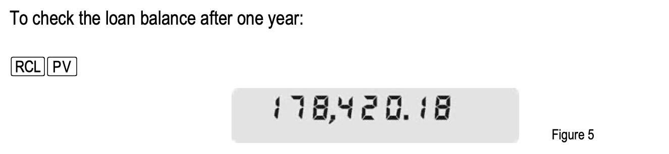  

Example 2:
Example 2 continues from Example 1 with the same TVM solution in memory, and the question becomes what is the principal value and interest paid after the second year of the loan:

To move the P1 and P2 period numbers from 1-12,  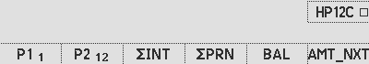  to 13-24, press :  AMT_NXT  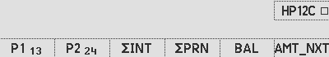  To get the amount of principal left to pay after 12 months:  The interest from month 13 to 24: press to get -13 767.7838. With HP12C ticked it is -13 767.79.  ΣINT  The principal paid after month 24: press which is -1 706.7207. With HP12C ticked it is -1 706.69.  ΣPRN  For the outstanding principal after 24 months, press : 176 713.4403. With HP12C ticked it is 176 713.49.  BAL | 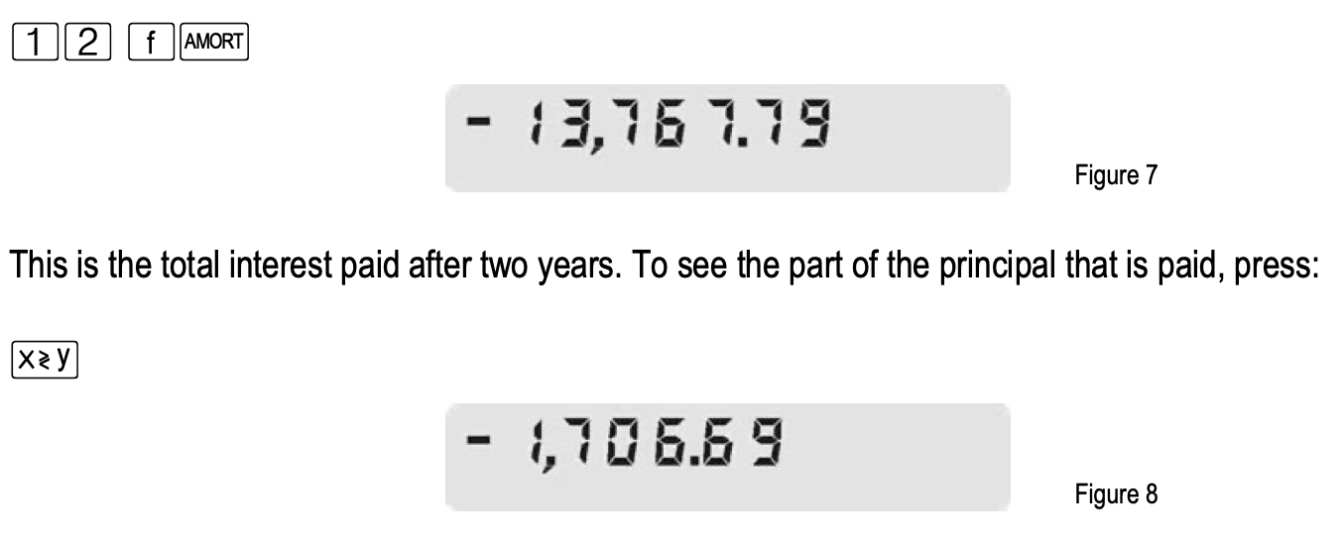  Move 12 periods on, to 13-24  During the second year  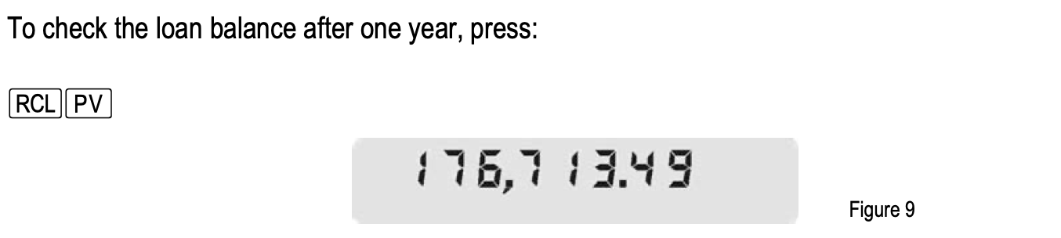  after two years    Note: We believe the descriptive text in this HP worked problem is incorrect but not the operations.

Numerical errors: The HP tutorial answers are as per HP12-C rounding. The C47/R47 answers were checked with a manual spreadsheet and are confirmed accurate.

Examples 3 & 4 may be followed in the HP guide.

Section 5: Duncan’s collection of TVM stress tests

SwissMicros Forum post of Duncan’s (dm319’s) problem set

From Duncan’s (DM319) post, relating to comparative tests for TVM on multiple calculators. Do follow the linked reference for updated results on all tested calculators: Table from quoted link, as of 2024-09-30, modified typographically. Added text in brown.
| # | Ref | N | I%YR | PV | PMT | FV | P/YR | Mode |
|----|------------|--------------|-----------|----------|--------------|-----------|------|-------|
| 1 | DM | 38 x 12 | 5.25% | 270'000 | ? | 0 | 12 | end |
| 1b | DM | 38 x 12 | ? | 270'000 | -14'584/12 | 0 | 12 | end |
| 2 | SlideRule | 360 | 15% → 12% | 100'000 | ?-? | 0 | 12 | end |
|----|------------|--------------|-----------|----------|--------------|-----------|------|-------|
HP Museum post. Calculate PMT, given n = 360, I%YR = 15%, PV = 100000, FV = 0, then calculate PMT again with I%YR = 12%. Subtract the two results, and put that back into PMT, then change n = 36 and I%YR = 15% again, and calculate PV.
|----|------------|--------------|-----------|----------|--------------|-----------|------|-------|
| 3 | Kahan 1983 | 60x60x24x365 | 10% | 0 | -0.01 | ? | =N | end |
|----|------------|--------------|-----------|----------|--------------|-----------|------|-------|
HP Museum post
|----|------------|--------------|-----------|----------|--------------|-----------|------|-------|
| 4 | DM | 480 | 0 → ? | 100'000 | ?→ PMT | 0 | 12 | end |
|----|------------|--------------|-----------|----------|--------------|-----------|------|-------|
Calculate PMT first given I%YR = 0, then re-input this back into PMT and calculate I%YR. On the HP-12c this is best done by pressing x<>y twice before putting back into PMT. On R47/C47 this is not required as the last solved value remains in the I/a register.
|----|------------|--------------|-----------|----------|--------------|-----------|------|-------|
| 5 | Dieter | 10 | ? | 50 | -30 | 400 | 1 | end |
| 6 | Dieter | 10 | ? | 50 | -30 | 80 | 1 | end |
|----|------------|--------------|-----------|----------|--------------|-----------|------|-------|
HP Museum post. Note that both have more than one solution.
|----|------------|--------------|-----------|----------|--------------|-----------|------|-------|
| 7 | A Chan | 10 | ? | -100 | 10 | 1e-10 | 12 | end |
|----|------------|--------------|-----------|----------|--------------|-----------|------|-------|
HP Museum post
|----|------------|--------------|-----------|----------|--------------|-----------|------|-------|
| 8 | Miguel | 32 | ? | -999'999 | 0 | 1e6 | 1 | end |
|----|------------|--------------|-----------|----------|--------------|-----------|------|-------|
HP Museum post
|----|------------|--------------|-----------|----------|--------------|-----------|------|-------|
| 9 | DM | ? | 25 | 100000 | -2083.333334 | 0 | 12 | end |
| 10 | DM | ? | 25 | 100000 | -2040.816327 | 0 | 12 | begin |
|----|------------|--------------|-----------|----------|--------------|-----------|------|-------|
|----|------------|--------------|-----------|----------|--------------|-----------|------|-------|
| 11 | robve | 60x24x365 | 1/6% → ? | 0 | -0.01 | ?→ FV | =N | end |
| 12 | robve | 40 | ? → I%YR | 900 | -400 | -1000 → ? | 1 | begin |
|----|------------|--------------|-----------|----------|--------------|-----------|------|-------|
HP Museum post. Calculate for FV first, re-input back to FV and compute I%YR. 12: Calculate for i first, re-input back into i and compute FV.

Results of Duncan’s TVM puzzle set as done by R47/C47, with accuracy of 34 digits

Results below from the 2026-02-23, R47/C47 version 00.109.03.01a0 pre-release, 46ea1e3:
34-digit Result R47/C47 (46ea1e3) | Reference answer
Dm319 Problem 1:  P1 PMT = -1368.148355350577572128828163198680 | -1368.148355350577572128828163198680147
Dm319 Problem 1b:  P1b I/a = 4.373218372310086835354687826497751 % | 4.373218372310086835354687826497750917
Dm319 Problem 2:  P2 PV = 6803.092161985597113625555764464722 | 6803.092161985597113625555764464722125
Dm319 Problem 3:  P3 FV = 331667.0066907768917803419084359626 | 331667.0066907768917803419084359625614
Dm319 Problem 4:  P4 PMT = -208.3333333333333333333333333333333  P4 I/a = -7.983367983367984007733887630459008E-34 % | -208.3333333333333333333333333333333333  -7.983367983367983367983367983367983792E-34
Dm319 Problem 5: First solution  P5 I/a = 14.43587132807995697420470129887705 % | 14.43587132807995697420470129887704551
Dm319 Problem 5: Second solution  P5b I/a= 53.17221326838472431046024137437116 % | 53.17221326838472431046024137437116064
Dm319 Problem 6: First solution  P6 I/a = -36.89336987417774420723991401135426 % | -36.89336987417774420723991401135425554
Dm319 Problem 6: Second solution  P6.2 I/a= 58.46195526622098709870320744645958 % | 58.46195526622098709870320744645958387
Dm319 Problem 7:  I/a = 2.181818181815801652892565878287002E-10 % | 2.181818181815801652892565878287002246E-10
Dm319 Problem 8:  I/a = 3.125001611329216004244745444268175E-06 % | 3.125001611329216004244745444268174638E-06
Dm319 Problem 9:  n = 1060.303390000510007127328529884891 | 1060.303390000510007127328529884890618
Dm319 Problem 10:  n = 1076.319544367706646435106131044347 | 1076.319544367706646435106131044347483
Dm319 Problem 11:  FV = 5260.382426000326494014090357828463  I%/a = 1.666666666666666666666666666666757E-01 % | 5260.382426000326494014090357828462763  1.666666666666666666666666666666757166E-01
Dm319 Problem 12a:  I%/a = 80.00000000098450919907260317672220 %  FV = -999.9999999999999999999995988604358 | 80.00000000098450919907260317672220395  -999.9999999999999999999995988604358347
R47/C47 results vs. correct theoretical answers.

Red digits show where the standard R47/C47 (with 51 internal decimal digits) reach the accuracy limit. Green digits correspond with the reference values. Blue digits show 3 extra digits, so rounding can be determined. Gray digits show the rounded first part result of a 2-part problem, fixed to being a 34-digit intermediate.

The R47/C47 can achieve full theoretical accuracy when custom compiled with 75 internal decimals, which increases TVM execution times with ca. 40%. Since 75 digits benefit only the pathological case such as P4, 51 digits are chosen for production software.

C47 & R47 relative performance on battery power, of Duncan’s tests above

Performance can be measured by speed and by accuracy. The relative metrics below:

TVM tested metrics
Model | TVM functions | Version | Speed | Accuracy
R47 | ALL, Formulas, 51d, N solver | 3,02a | 100% | 100%
C47 | ALL, Formulas, 51d, N solver | 3,02a | 100% | 100%
C47 p2 | ALL, Formulas, 39d, N solver | 3,02a | 53% | 95%
C47 p1, 3, 4 | 39d solver | 3,02a | 24% | 95%
Currently available binaries with TVM performance

For good reference, the recent history of R47/C47 performance metrics are listed below with version numbers:

TVM tested metrics
Model | TVM functions | Version | Speed | Accuracy
R47 | ALL, 51d | 3,01 | 100% | 100%
C47 | ALL, 51d | 3,01 | 100% | 100%
R47 | Formulas | 3,00 | 68% | 88%
R47 | 34d solver | 2,07 | 67% | 88%
C47n | 34d solver | 2,07 | 65% | 82%
C47 p4 | Formulas, 39d solver | 3,01 | 59% | 95%
C47p4 * | Formulas, 39d solver | 3,01 | 59% | 99%
C47 p2 | Formulas, 39d N solver | 3,01 | 53% | 95%
C47p2 * | Formulas, 51d N solver | 3,01 | 42% | 100%
C47 p3 | 39d N solver | 3,01 | 29% | 95%
C47 | 34d solver | 2,07 | 26% | 82%
C47p3 * | 51d N solver | 3,01 | 25% | 100%
C47 p1 | 39d solver | 3,01 | 24% | 95%
C47p1 * | 51d solver | 3,01 | 19% | 99%
C47 | 34d solver | 2,00 | 18% | 77%
C47 | Older version, all function |  |  | 34 digits
C47p1-4 | Packaged functions |  |  | 39 digits
C47p1-4 * | Special high precision test compiles |  |  | 51 digits
C47 / R47 | New DM42n hardware / R47 hardware |  |  | 51 digits
C47 / R47 | New DM42n hardware / R47 hardware |  |  | 51 digits
Formulas | Explicit analytical TVM solving formulas where possible
34d solver | Original WP43 solver, register based, 34-digit
39d solver | 39-digit Brent solver
51d/39d N solver | Upgraded 39 / 51 digit solver using Newton-Raphson & Brent

TVM accuracy and speed of the R47/C47 calculators

Table: Tested TVM accuracy in digits:
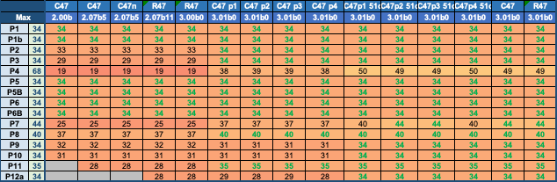
Number of accurate digits, example: 123000.0 has 34 digits, and 0.00123 has 34+3 digits.

Non-standard digit counting is used for comparisons:

  - For n ≥ 1, counting begins at the first non-zero digit and totals 34 digits.
  - For n < 1, counting begins at “0.”, and the total digit count is defined as:
    - – exponent + 34, with ‘exponent’ from the normalized scientific notation.
  - Thus, 1.23E−2 = 0.0123 counts 2 + 34 digits and 1.23E−40 counts 40 + 34 digits.
  - This enables meaningful comparison of small floating-point values, such as P4, whose 34 significant digits begin only at the 35th digit after the radix.

TVM operating times in seconds, on battery, for good measurement (USB power is just too fast to record). Time measurements were done internally using the LASTT command as timer:

Table: TVM operating times in seconds:
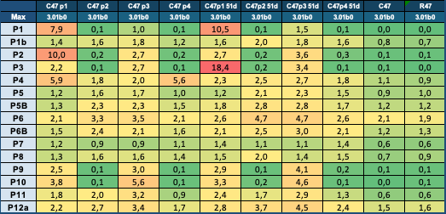

Duncan’s TVM problems, programmed on C47 / R47

These problems were solved using RPN programs, illustrating the use thereof on R47/C47: All programs are included in the distro as loadable programs with a state file containing all programs needed to run the tests. Run the test wit ‘PAll':

Dm319 Problem 1:  N=456, i%/a=5.25, PV=270000, PMT=??, FV=0, pp/a=12, cp/a=12, END.  0001: LBL 'P1'  0002: 38  0003: 12  0004: *  0005: STO 'NPPER'  0006: 5.25  0007: STO 'I%/a'  0008: 270 000  0009: STO 'PV'  0010: 0  0011: STO 'PMT'  0012: 0  0013: STO 'FV'  0014: 12  0015: STO 'PPER/a'  0016: STO 'CPER/a'  0017: ENDP  0018: PMT  0019: END | Dm319 Problem 1b:  N=456, i%/a=??, PV=270000, PMT=-14584/12, FV=0, pp/a=12, cp/a=12, END.  0001: LBL 'P1b'  0002: 38  0003: 12  0004: *  0005: STO 'NPPER'  0006: 0  0007: STO 'I%/a'  0008: 270 000  0009: STO 'PV'  0010: -14 584  0011: 12  0012: /  0013: STO 'PMT'  0014: 0  0015: STO 'FV'  0016: 12  0017: STO 'PPER/a'  0018: STO 'CPER/a'  0019: ENDP  0020: I/a  0021: END

Dm319 Problem 2:  1st solve: N=360, i%/a=15, PV=100000, PMT=??, FV=0, pp/a=12, cp/a=12, END.  2nd solve: PMT solved, i%/a = 12, PMT=??  3nd solve: PMT is calculated, i%/a = 15, PV=??  0001: LBL 'P2'  0002: 360  0003: STO 'NPPER'  0004: 15  0005: STO 'I%/a'  0006: 100 000  0007: STO 'PV'  0008: 0  0009: STO 'FV'  0010: 12  0011: STO 'PPER/a'  0012: STO 'CPER/a'  0013: ENDP  0014: 0  0015: STO 'PMT’ ; Bias the value needed  0016: PMT  0017: 12  0018: STO 'I%/a'  0019: DROPX  0020: PMT  0021: -  0022: STO 'PMT'  0023: 36  0024: STO 'NPPER'  0025: 15  0026: STO 'I%/a'  0027: PV  0028: END | Dm319 Problem 3:  N=31536000, i%/a=10, PV=0, PMT=-0.01, FV=??, pp/a=31536000, cp/a=31536000  0001: LBL 'P3'  0002: 60  0003: X^2  0004: 24  0005: *  0006: 365  0007: *  0008: STO 'NPPER'  0009: STO 'PPER/a'  0010: STO 'CPER/a'  0011: 10  0012: STO 'I%/a'  0013: 0  0014: STO 'PV'  0015: -0.01  0016: STO 'PMT'  0017: ENDP  0018: FV  0019: END

Dm319 Problem 4:

Solve 1: N=480, i%/a=0, PV=100000, PMT=??, FV=0, pp/a=12, cp/a=12, END.

Solve 2: All remains the same, I/a=?

0001: LBL 'P4'
0002: 480
0003: STO 'NPPER'
0004: 0
0005: STO 'I%/a'
0006: 100 000
0007: STO 'PV'
0008: 0
0009: STO 'PMT'
0010: STO 'FV'
0011: 12
0012: STO 'PPER/a'
0013: STO 'CPER/a'
0014: ENDP
0015: PMT
0016: I/a
0017: END

Dm319 Problem 5: First solution  Default result, without biasing the solver.  0001: LBL 'P5'  0002: 10  0003: STO 'NPPER'  0004: 0  0005: STO 'I%/a'  0006: 50  0007: STO 'PV'  0008: -30  0009: STO 'PMT'  0010: 400  0011: STO 'FV'  0012: 1  0013: STO 'PPER/a'  0014: STO 'CPER/a'  0015: ENDP  0016: I/a  0017: END | Dm319 Problem 5: Second solution  The key to the second solution is to point the solver to closer to the expected second result, i.e. store 50 in I%/a to make it search starting at 50. See brown:  0001: LBL 'P5b'  0002: 10  0003: STO 'NPPER'  0004: 0  0005: STO 'I%/a'  0006: 50  0007: STO 'PV'  0008: -30  0009: STO 'PMT'  0010: 400  0011: STO 'FV'  0012: 1  0013: STO 'PPER/a'  0014: STO 'CPER/a'  0015: ENDP  0016: 50  0017: STO 'I%/a'  0018: DROPX  0019: I/a  0020: END
Dm319 Problem 6: First solution  Biasing the solver to -36, see brown:  0001: LBL 'P6'  0002: 10  0003: STO 'NPPER'  0004: 0  0005: STO 'I%/a'  0006: 50  0007: STO 'PV'  0008: -30  0009: STO 'PMT'  0010: 80  0011: STO 'FV'  0012: 1  0013: STO 'PPER/a'  0014: STO 'CPER/a'  0015: ENDP  0016: -36  0017: STO 'I%/a'  0018: I/a  0019: END | Dm319 Problem 6: Second solution  The key to the second solution is to bias the solver to closer to the expected second result, i.e. store 50 in I%/a to make it search starting at 50. See brown:  0001: LBL 'P6b'  0002: 10  0003: STO 'NPPER'  0004: 0  0005: STO 'I%/a'  0006: 50  0007: STO 'PV'  0008: -30  0009: STO 'PMT'  0010: 80  0011: STO 'FV'  0012: 1  0013: STO 'PPER/a'  0014: STO 'CPER/a'  0015: ENDP  0016: 50  0017: STO 'I%/a'  0018: DROPX  0019: I/a  0020: END

Dm319 Problem 7:  0001: LBL 'P7'  0002: 10  0003: STO 'NPPER'  0004: 0  0005: STO 'I%/a'  0006: -100  0007: STO 'PV'  0008: 10  0009: STO 'PMT'  0010: 1.*10^-10  0011: STO 'FV'  0012: 12  0013: STO 'PPER/a'  0014: STO 'CPER/a'  0015: ENDP  0016: I/a  0017: END | Dm319 Problem 8:  0001: LBL 'P8'  0002: 32  0003: STO 'NPPER'  0004: 0  0005: STO 'I%/a'  0006: -999 999  0007: STO 'PV'  0008: 0  0009: STO 'PMT'  0010: 1.*10^6  0011: STO 'FV'  0012: 1  0013: STO 'PPER/a'  0014: STO 'CPER/a'  0015: ENDP  0016: I/a  0017: END
Dm319 Problem 9:  0001: LBL 'P9'  0002: 0  0003: STO 'NPPER'  0004: 25  0005: STO 'I%/a'  0006: 100 000  0007: STO 'PV'  0008: -2 083.333 334  0009: STO 'PMT'  0010: 0  0011: STO 'FV'  0012: 12  0013: STO 'PPER/a'  0014: STO 'CPER/a'  0015: ENDP  0016: n  0017: END | Dm319 Problem 10:  0001: LBL 'P10'  0002: 0  0003: STO 'NPPER'  0004: 25  0005: STO 'I%/a'  0006: 100 000  0007: STO 'PV'  0008: -2 040.816 327  0009: STO 'PMT'  0010: 0  0011: STO 'FV'  0012: 12  0013: STO 'PPER/a'  0014: STO 'CPER/a'  0015: BeginP  0016: n  0017: END

Dm319 Problem 11:  0001: LBL 'P11'  0002: REM 'Problem 11, first calculate FV then I/a'  0003: 60  0004: 24  0005: 365  0006: *  0007: *  0008: STO 'NPPER'  0009: STO 'PPER/a'  0010: STO 'CPER/a'  0011: 1  0012: 6  0013: /  0014: STO 'I%/a'  0015: 0  0016: STO 'PV'  0017: -0.01  0018: STO 'PMT'  0019: ENDP  0020: FV  0021: I/a  0022: END | Dm319 Problem 12a:  Force interest to positive root: bias 55  0001: LBL 'P12a'  0002: REM 'Problem 12 first do I/a then FV'  0003: 40  0004: STO 'NPPER'  0005: 900  0006: STO 'PV'  0007: -400  0008: STO 'PMT'  0009: -1 000  0010: STO 'FV'  0011: 1  0012: STO 'PPER/a'  0013: STO 'CPER/a'  0014: BeginP  0015: 55  0016: STO ‘I%/a’  0017: I/a  0018: FV  0019: END

Sequencing program ‘Pall’:  Run all problem files and reporting results and time durations of processing:  0001: LBL 'Pall'  0002: 0  0003: STO 01  0004: XEQ 'P1'  0005: 'TVM P1:'  0006: XEQ 'TT'  0007: XEQ 'P1b'  0008: 'TVM P1b:'  0009: XEQ 'TT'  0010: XEQ 'P2'  0011: 'TVM P2:'  0012: XEQ 'TT'  0013: XEQ 'P3'  0014: 'TVM P3:'  0015: XEQ 'TT'  0016: XEQ 'P4'  0017: 'TVM P4:'  0018: XEQ 'TT'  0019: XEQ 'P5'  0020: 'TVM P5:'  0021: XEQ 'TT'  0022: XEQ 'P5b'  0023: 'TVM P5B(50):'  0024: XEQ 'TT'  0025: XEQ 'P6'  0026: 'TVM P6:'  0027: XEQ 'TT'  0028: XEQ 'P6b'  0029: 'TVM P6B(50):'  0030: XEQ 'TT'  0031: XEQ 'P7'  0032: 'TVM P7:'  0033: XEQ 'TT'  0034: XEQ 'P8'  0035: 'TVM P8:'  0036: XEQ 'TT'  0037: XEQ 'P9'  0038: 'TVM P9:'  0039: XEQ 'TT'  0040: XEQ 'P10'  0041: 'TVM P10:'  0042: XEQ 'TT'  0043: XEQ 'P11'  0044: 'TVM P11:'  0045: XEQ 'TT'  0046: XEQ 'P12a'  0047: 'TVM P12a:'  0048: XEQ 'TT'  0049: END | Subroutine ‘TT’:  Print results to text files:  0001: LBL 'TT'  0002: LASTT  0003: STO 00  0004: DROPX  0005: Printxy  0006: RCL 00  0007: RCL 01  0008: -  0009: 10.0  0010: /  0011: ' Sec'  0012: SIG 02  0013: +  0014: Printx  0015: RCL 00  0016: STO 01  0017: END

Original 012: 2024-06-01, on C47 version 00.109.02.00
Updated 012a: 2025-04-22, on C47 version 00.109.00.07b5
Updated 012b: 2026-02-05, on R47/C47 version 00.109.03.00
Updated 012c: 2026-02-22, on R47/C47 version 00.109.03.01
Updated 012d: 2026-02-25, on R47/C47 version 00.109.03.01

Author Jaco Mostert; Proofread by Duncan Murray
Copyright (C) 2026 The R47/C47 Development Team. Permission is granted to copy, distribute and/or modify this document under the terms of the GNU Free Documentation License, Version 1.3 or any later version published by the Free Software Foundation; with no Invariant Sections, no Front-Cover Texts, and no Back-Cover Texts. A copy of the license can be downloaded from gnu.org.
Quoted yellow portions copyright to CC NC4.0 license as stated in referenced document.

Business Finance Essentials, TVM 5-Key Approach Guided Tutorial with HP10BII+, Dr. Kevin Bracker; Dr. Fang Lin; and J Pursley
HP.COM: HP12C Platinum Loan Amortizations, or on the Wayback Machine Archive
WolframAlpha Web check: WA
TVM check Python3
WolframAlpha Web check: WA
TVM check: WA Notebook: N[(1/100) * 315360000 * ((315360001 / 315360000)^31536000 - 1), 40]
The precise result is 0 but cannot be achieved due to the input rounding at 34 digits, as well as internal rounding at 51 digits
TVM check Python3
TVM check Python3
TVM check Python3
TVM check Python3
TVM check Python3
TVM check Python3
TVM check: WA Notebook: N[-Log[1 – 1E5 * 25 / (1200 * 2083333334/1E6)] / Log[1225/1200], 40]
TVM check: WA Notebook: N[-Log[1 - 2500000000000 / (2040816327 * 1225)] / Log[1225/1200], 40]
WolframAlpha Web check: WA
TVM check Python3

